**Project Title: Digital Clock**

**Semester Project: Microprocessor System**

**Course Instructor:** Sir Jameel Nawaz

**Lab Instructor:** Shaiza Malik

**Gorup Members**

|  |  |  |
| --- | --- | --- |
| **Sr. no** | **Name** | **CMS ID** |
| **1.** | Muhammad Umair | 405215 |
| **2.** | Irfa Farooq | 412564 |

Dedication

In the name of Allah, who is the most giving and merciful, the Almighty and powerful.

In gracious appreciation and love for my teachers and guides and a special thanks to Sir Jameel Nawaz, and Ma’am Shaiza Malik for the guidance and motivation to complete this duty bestowed upon me.

In love with our parents, family members and our friends who helped us a lot in learning new things.

This is the proposal of semester project of MPS EE-222 of the Spring Semester 2024 done by Muhammad Umair and Irfa Farooq.

Acknowledgement

We would like to thank Sir Jameel Nawaz and Ma’am Shaiza Malik for teaching us the concepts of Micro-processor system and teaching us a hands-on experience on microprocessor. Because of them we were able to make a fun project like Digital clock.

Regards,

Muhammad Umair

Irfa Farooq

Abstract

This proposal is for the project that aims to develop a digital clock using an ATmega16 microcontroller. The clock will display time on Liquid Crystal Display (LCD) integrated with microcontroller. Also, there is a keypad attached with the microcontroller for the time input and settings. The primary objective is to create a functional and efficient timekeeping device that offers accuracy and reliability. The ATmega16 microcontroller will serve as the central processing unit, managing the LCD display and interpreting the keyboard inputs to set and adjust the time. This project combines hardware and software components to design a compact and versatile digital clock suitable for various applications. The utilization of the ATmega16 microcontroller ensures robust performance, while the LCD and keyboard interfaces enhance user interaction, making time management straightforward and accessible.

Table of Contents

Contents

1. Introduction 1

1.1 Overview of Project 1

1.2 Block Diagram of Complete System (Just use simple blocks) 1

1. Design 2

2.1 Problem Statement 2

2.2 Simulation and complete logic circuit 2

1. Hardware Implementation 3

3.1 Schematic Diagram 3

3.2 Index of ICs used 3

3.3 Details of Other Components used like diodes, transistors, resistors etc. 3

1. Project Applications Further Suggestions (Optional) 4
2. Future Recommendations 5

References / Bibliography 6

# Introduction

## Overview of Project

The project is about designing and implementing clock in an innovative way. For the time setting we will use keypad and display the time on the LCD display. For this purpose, we require a microcontroller that ensures the correct time display on the LCD display and manages the input for the user. For this project we are using AtMega16.

## Block Diagram of Complete System (just use simple blocks)

**AtMega16 Microcontroller**

**LCD Display**

**Keypad for the user to change the time setting**

**Figure 1: Block Diagram**

# Design

## Problem Statement

The purpose of this project is to implement all the knowledge gained in class and lab. We want to use timers, interrupts, port or pins for inputs and outputs. Also, we want to connect the input and output devices with the microcontroller.

In clock we can use timers, interrupts and connect the input, output devices with the microcontroller. We can use the keyboard as the input device and for output we can use the LCD display. Timers will be used to generate delays. Interrupts will be used during time delay and device connection.

## Simulation and Complete logic circuit

The stimulation and the logical diagram is still in the design process and will be presented at the presentation.

# Hardware Implementation

## Detailed Schematic of Design and its Description

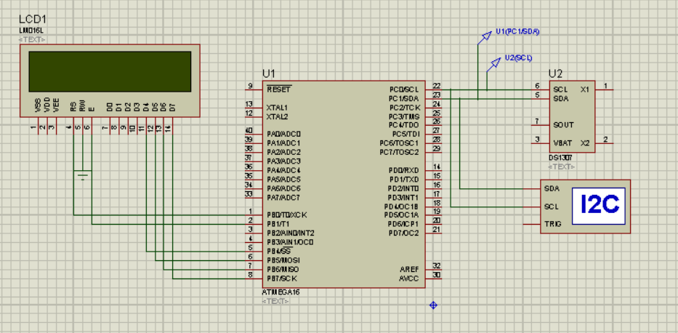

## Details of ICs used:

We will be using 1 chip of AtMega16 microcontroller along with some additional components.

## Details of Other Components used like diodes, transistors, resistors etc.

The detail of other components is as follows:

1. LCD Display
2. Alarm
3. Keypad
4. Resistors

# Project Applications

* **Study Purposes**

The project is for study purposes and to gain experience of coding microcontroller and hardware implementation.

* **Electrical Appliance automation**

We have the alarm clock that turns on buzzer when the set time is reached. Instead of turning on the buzzer for alarm we can design the basic electrical circuits and automatically turn off Owen when the cooking time completes. There are so many applications in which we can use the alarm function of clock to automatically turn off and on the devices.

* **Study Timer for Students**

Students can use the same project to monitor the study time as they can use a stopwatch to record the time during which they are studying.

* **Sleep Monitoring**

We can use the stopwatch function of clock to monitor sleep. The clock will store the time and tell the user about the time of sleep

Apart from this there are many applications of this project, also it is a part of industrial projects.

# Future Recommendations

Following are the few future recommendations:

* We can have a bigger microcontroller like AtMega16 or another microcontroller.
* We can add date and day feature to our project.
* We can increase the display size.
* We can design the same project for commercial use.
* We can add new and exciting features to it.

# References / Bibliography

The idea of the projects was taken from these websites. We have used the basic idea for these websites. We have combined basic ideas with our knowledge to make this project

* <https://www.electronicwings.com/avr-atmega/real-time-clock-rtc-ds1307-interfacing-with-atmega16-32>
* <https://hackaday.io/project/3511-pavapro-portable-avr-programmer/log/12205-keyboard-works-target-avr-programmed>